IT5022 – Fundamentals of Machine Learning
Programming Assignment Project Report
Customer Churn Prediction using Logistic Regression and Random Forest

S. M. M. S. Jayawardhana
MS26902302
K. P. U. M. S. Ranathunge
MS26919478

Table of Contents
1. Introduction 1
2. Dataset Description 1
3. Exploratory Data Analysis (EDA) 2
4. Methodology 3
4.1. Model 1: Logistic Regression 3
4.1.1. Model Overview and Methodology 3
4.1.2. Results and Analysis 6
4.1.3. Confusion Matrix Analysis 6
4.1.4. Logistic Regression Summary 8
4.2. Model 2: Random Forest 8
4.2.1. Model Overview and Methodology 8
4.2.2. Results and Analysis 9
4.2.3. Comparative Analysis 10
4.2.4. Confusion Matrix Analysis 11
5. Results and Discussion 12
6. Conclusion 13
7. Future Work 13
8. Appendix 14
9. References 51

List of Tables
Table 1 : Baseline Model classification report 3
Table 2 : Performance metrics of the four Logistic Regression models on the test set 6
Table 3 : Performance metrics of the four Random Forest models on the test set. 9
Table 4 : Performance metrics of the best-performing Random Forest and Logistic Regression models. 12

List of Figures
Figure 1 : Customer Churn Distribution 2
Figure 2 : Confusion Matrix for LR 7
Figure 3 : Bar chart comparing the performance metrics across the four Random Forest models 10
Figure 4 : Confusion matrix for Baseline model Vs best performing model 11

Introduction
Customer churn refers to the situation where customers stop using a company’s services. It is a major challenge in many industries such as telecommunications, banking, and subscription-based businesses. Losing existing customers can be costly. In many cases it costs more to replace a customer than to retain one. Because of this predicting churn has become very important. It helps businesses take early action, use resources wisely, and improve customer value over time.
This project focuses on building and comparing supervised machine learning models for churn prediction. Two algorithms are considered.The algorithms are Random Forest and Logistic Regression. Random Forest is an ensemble method. It is known for its strength in handling complex patterns and reducing overfitting. Logistic Regression is a simpler linear model. It is easy to interpret.I is often used as a baseline for classification tasks. By comparing these two models, this study aims to find the most suitable approach for the given dataset.
The rest of this report explains the overall methodology. It begins with a description of the dataset and an exploratory data analysis (EDA) to identify key patterns. Next the training and evaluation processes for both models are discussed. After that the best models are compared in detail along with their results and key findings. The report ends with conclusions and suggestions for future improvements.

Dataset Description
The dataset used in this study is a publicly available Customer Churn Dataset obtained from Kaggle. It consists of 10,000 anonymized customer records. Eachencompassing various demographic, service usage, and contractual attributes. The primary objective of this dataset is to predict customer churn.It is represented by a binary target variable, Exited. A value of 1 for Exited indicates that the customer has churned.While 0 indicates that the customer has stayed
The class distribution within the dataset reveals a significant imbalance, which is characteristic of many real-world churn prediction scenarios. Specifically, out of the 10,000 records:

Stayed (non-Churners): 7,963 records (approximately 80%)
Churned (Churners): 2,037 records (approximately 20%)

Exploratory Data Analysis (EDA)
Exploratory Data Analysis (EDA) was conducted to gain a deeper understanding of the dataset's characteristics, identify potential relationships between features and the target variable, and detect any anomalies or patterns that could influence model performance.

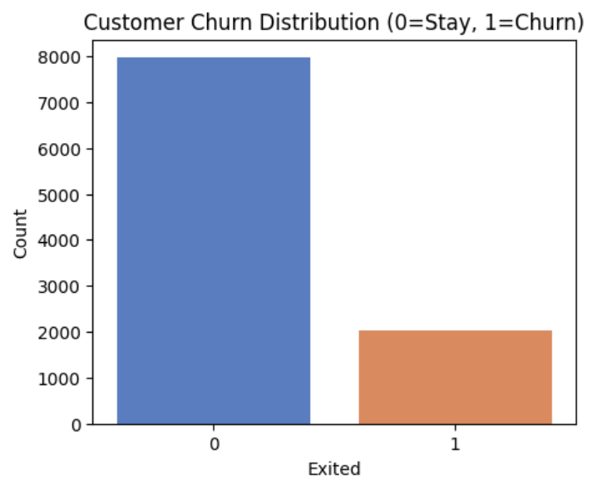
Figure 1 : Customer Churn Distribution

Churn (1) vs. Stay (0) counts: {0: 7963, 1: 2037}
A main observation was the significant class imbalance within the target variable.The majority of customers (approximately 80%) did not churn. This imbalance underscores the necessity for employing specific techniques during model training to prevent bias towards the majority class. And ensure accurate prediction of the minority (churn) class.
Correlation and Influence: Analysis revealed notable correlations between certain features and customer churn. Age and Balance were identified as influential factors impacting to churn. This suggests that these variables play a crucial role in customer retention dynamics.
Distributional Tendencies: Further examination of feature distributions indicated that older customers exhibited a higher tendency to churn. This insight points towards potential demographic segments that may require targeted retention strategies.

Methodology

Model 1: Logistic Regression
Logistic Regression is a widely used classification algorithm that models the probability of a binary outcome, making it suitable for customer churn prediction. Due to its simplicity and interpretability, it serves as a strong baseline for comparison with more complex models. This section presents a step-by-step analysis of Logistic Regression models, starting from a basic implementation and progressing toward improved versions that address class imbalance and optimize performance.
The same dataset split was used as in previous models, ensuring consistency in evaluation. The primary objective is to examine how different techniques, such as class weighting, resampling, and hyperparameter tuning affect the model’s ability to correctly identify churned customers.

Model Overview and Methodology
The modeling process followed a progressive approach, beginning with a baseline model and then introducing improvements to overcome its limitations, particularly the issue of class imbalance.
- Model 1: Baseline Model
Baseline Model Classification Report:
Table 1 : Baseline Model classification report
Class | Precision | Recall | F1‑Score | Support
0 (Stay) | 0.804 | 0.966 | 0.878 | 1593
1 (Churn) | 0.379 | 0.081 | 0.134 | 407
The initial model was developed using Logistic Regression with default parameters and without addressing the issue of class imbalance. Standard preprocessing steps were applied, including handling missing values and encoding categorical variables. The baseline model achieved an accuracy of 78.6%, which may seem acceptable at first glance. However, this overall accuracy does not reflect the model’s performance across different classes. While the model performs well in identifying non‑churn customers (class 0), it performs poorly when predicting churn customers (class 1). This is evident from the low recall of 0.081 and an F1‑score of 0.134 for churn customers, indicating that most actual churn cases are not being detected. This poor performance is largely due to the highly imbalanced nature of the dataset, where the number of customers who stay significantly outweighs those who churn. As a result, the model becomes biased toward predicting the majority class. This situation illustrates the accuracy paradox, where a model can achieve high overall accuracy while failing to perform well on the most critical class, which in this case is the churn customers.

Analysis of the Baseline Logistic Regression Model
In this dataset, customer churn represents a minority but high‑impact class. The baseline Logistic Regression model primarily learns patterns from non‑churn customers, allowing it to predict “stay” very effectively but at the cost of missing most churners.
Although Logistic Regression is well‑suited for binary classification and provides good interpretability, it assumes balanced class distributions by default. Without adjustment, the model minimizes overall error by favoring the majority class. For churn prediction, this is problematic because false negatives (missed churners) are more costly than false positives.
Key observations from baseline analysis:
- High accuracy is driven by correct prediction of non‑churn customers
- Very low recall indicates poor churn detection
- Model bias reflects the underlying imbalance in the dataset
- Accuracy alone is not sufficient for evaluating churn models

- Model 2: Class-Weighted Logistic Regression
To overcome the shortcomings identified in the baseline model, Model 2 introduces class weighting to address the issue of class imbalance. By using the class_weight parameter, higher importance is given to the minority class during training, which means that misclassifying churn customers is penalized more heavily than before.
This modification leads to a noticeable improvement in the model’s ability to identify churners. In particular, the recall for the churn class increases significantly to approximately 0.67, indicating that the model now captures a much larger proportion of actual churn cases. At the same time, overall accuracy drops to around 0.71, reflecting a trade‑off introduced by prioritizing churn detection.
The reduction in accuracy occurs because the model now sacrifices some correct non‑churn predictions in order to better detect churn customers. This trade‑off is generally acceptable in real business scenarios, where identifying at‑risk customers is more valuable than maintaining high overall accuracy. As a result, Model 2 is better aligned with business objectives and provides a more practical solution for churn prediction.
- Model 3: SMOTE (Synthetic Minority Over-sampling Technique)
Model 3 investigates a data‑level solution to the class imbalance problem by using the Synthetic Minority Over‑sampling Technique (SMOTE). Rather than changing how the model learns through its parameters, SMOTE works by creating synthetic examples of the minority class. These new samples are generated by interpolating between existing churn cases, which helps balance the training dataset.
By training the model on this more balanced data, its ability to generalize improves noticeably. The recall for churn customers increases to around 0.66, while overall accuracy remains close to 0.71. This shows that the model is able to detect churn customers much more effectively without a significant loss in overall performance.
The results are very similar to those achieved with the class‑weighted model, suggesting that both resampling methods like SMOTE and cost‑sensitive learning approaches are effective ways to handle class imbalance in this dataset. This also highlights that different imbalance‑handling strategies can lead to comparable improvements in churn prediction when applied correctly.
- Model 4: Hyperparameter Tuning (GridSearchCV)
The final model, referred to as Model 4, further improves performance by applying hyperparameter tuning. To achieve this, GridSearchCV was used to systematically test different combinations of hyperparameters using cross‑validation. This process helps identify the most effective model configuration while reducing the risk of overfitting.
The optimal set of parameters selected through this search includes a regularization strength of C = 10, the saga solver, and balanced class weights to account for class imbalance. With these settings, the tuned model demonstrates stronger discriminative performance.
In particular, the model achieves an AUC score of approximately 0.74–0.75, which indicates an improved ability to distinguish between churners and non‑churners across different decision thresholds. At the same time, both accuracy and recall remain consistent with the earlier improved models, showing that tuning enhances overall model quality without sacrificing previously gained improvements in churn detection.

Results and Analysis
The performance of the four Logistic Regression models was evaluated on the testing set (20% of the dataset) using standard classification metrics: Accuracy, Precision, Recall, and F1-Score. The results are summarized in Table 2.
Table 2 : Performance metrics of the four Logistic Regression models on the test set
Model | Description | Accuracy | Precision | Recall | F1-Score
Model 1 | Baseline (Default Parameters) | 0.786 | 0.379 | 0.081 | 0.134
Model 2 | Class Weights | 0.709 | 0.379 | 0.671 | 0.484
Model 3 | SMOTE | 0.714 | 0.383 | 0.668 | 0.487
Model 4 | SMOTE + GridSearchCV (Tuned Model) | 0.709 | 0.379 | 0.671 | 0.484
The baseline model (Model 1) achieves the highest overall accuracy of 0.786. However, this performance is primarily driven by its strong ability to correctly classify non-churn customers, while it performs poorly in identifying churn cases, as reflected by the very low recall of 0.081.
In contrast, Models 2, 3, and 4 show a significant improvement in recall, with values around 0.66–0.67. This indicates a much stronger ability to detect churn customers. Although these models exhibit a slight reduction in overall accuracy, they provide more balanced performance across both classes.
Among the improved models, Model 3 (SMOTE) achieves the highest accuracy (0.714) and F1-score (0.487), suggesting a slightly better balance between precision and recall. Overall, the results demonstrate that handling class imbalance through class weighting or SMOTE substantially enhances the model’s effectiveness for churn prediction.

Confusion Matrix Analysis
The confusion matrix for the baseline model provides further insight into its performance:
- 1539 True Negatives: non-churn customers correctly predicted
- 33 True Positives: churn customers correctly predicted
- 374 False Negatives: churn customers incorrectly predicted as non-churn
- 54 False Positives: non‑churn customers incorrectly predicted as churn
The confusion matrix for the baseline model clearly highlights its weaknesses in predicting customer churn. While the model performs well in identifying non‑churn customers, it struggles significantly with detecting actual churners.
From the results, the model correctly classifies 1,539 True Negatives, meaning non‑churn customers are accurately predicted as staying. It also correctly identifies 33 True Positives, showing that only a small number of churn customers are successfully detected. However, there is a notably high number of 374 False Negatives, where customers who actually churn are incorrectly predicted as non‑churners. This indicates a serious recall issue, as the model fails to capture a large portion of customers who are at risk of leaving.
In a real banking context, this imbalance is problematic because missed churners represent lost opportunities for proactive retention strategies. These customers leave without intervention, which can have a direct negative impact on revenue. Overall, the confusion matrix clearly demonstrates why relying only on accuracy is misleading and emphasizes the importance of recall and class‑specific evaluation metrics when building effective churn prediction models.

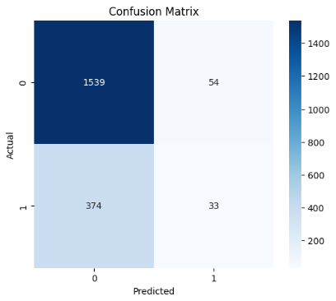
Figure 2 : Confusion Matrix for LR

Logistic Regression Summary
Overall, the baseline Logistic Regression model establishes a useful benchmark but performs poorly in detecting churn due to class imbalance. The introduction of class weighting, SMOTE, and hyperparameter tuning significantly improves recall, which is the most critical metric for churn prediction.
Although these improvements result in a slight reduction in overall accuracy, they produce models that are far more effective in identifying customers at risk of leaving. This demonstrates that handling class imbalance is essential for building practical and reliable churn prediction models using Logistic Regression.

Model 2: Random Forest
The Random Forest algorithm is an ensemble learning method. It constructs a multitude of decision trees during training and outputs the mode of the classes for classification tasks. It is highly effective in handling complex datasets with non-linear relationships.It is also robust against overfitting. This section presents a detailed analysis of four distinct Random Forest models developed for churn prediction. The dataset utilized for this study was partitioned into three parts. 75% for training, 15% for testing, and 10% for validation. The primary objective is to evaluate the impact of various techniques, such as hyperparameter tuning and class imbalance handling, on model performance.

Model Overview and Methodology
The predictive models were developed using a systematic approach.First, a baseline model was created and then advanced techniques were added step by step to address specific performance bottlenecks. A key focus was handling class imbalance in churn datasets.
- Model 1: Baseline Random Forest
The initial model (Model 1) was implemented using the Random Forest algorithm with default parameters. First before the training, the dataset underwent standard preprocessing steps. Preprocessing steps included the imputation of missing values and the encoding of categorical variables. The primary goal of this baseline model was to establish a performance benchmark. The model achieved a relatively high overall accuracy.It exhibited a significant deficiency in recall for the minority class (churned customers). This indicated that the model was biased towards the majority class and It struggled to identify actual churn instances effectively.
- Model 2: Class Weight Adjustment and Hyperparameter Tuning
To mitigate the poor recall observed in the baseline model, Model 2 incorporated techniques to handle class imbalance and optimize model parameters. The class_weight parameter was used to assign higher importance to the minority class during the training phase, thereby penalizing misclassifications of churned customers more heavily. Hyperparameter tuning was conducted using GridSearchCV. This process involved testing multiple combinations of hyperparameters through cross-validation.The optimal set selected based on the F1-score to ensure a balanced trade-off between precision and recall.
- Model 3: Synthetic Minority Over-sampling Technique (SMOTE)
Model 3 explored an alternative approach to address class imbalance. Synthetic Minority Over-sampling Technique (SMOTE) was applied in model 3. SMOTE generates synthetic samples for the minority class without adjusting class weights. It was done by interpolating between existing instances. This technique balances the class distribution in the training set. It aims to improve the model's ability to generalize and correctly identify churn cases without simply duplicating existing data points.
- Model 4: SMOTE with Hyperparameter Tuning
The final model (Model 4) combined SMOTE with the hyperparameter tuning. After balancing the dataset using SMOTE, GridSearchCV was used to fine-tune the Random Forest hyperparameter. Hyper parameters such as the number of estimators (trees) and the maximum depth of the trees were tuned during the training. This approach aimed to maximize the model's predictive capabilities by providing both a balanced training set and an optimized model architecture.

Results and Analysis
The performance of the four models was evaluated on the testing set (15% of the dataset) using standard classification metrics: Accuracy, Precision, Recall, and F1-Score. The results are summarized in Table 3 and visualized in Figure 3.
Table 3 : Performance metrics of the four Random Forest models on the test set.
Model | Description | Accuracy | Precision | Recall | F1-Score
Model 1 | Baseline (Default Parameters) | 0.8093 | 0.6107 | 0.2540 | 0.3587
Model 2 | Class Weights + GridSearchCV | 0.7700 | 0.4479 | 0.5639 | 0.4993
Model 3 | SMOTE (Default Parameters) | 0.7260 | 0.3801 | 0.5508 | 0.4498
Model 4 | SMOTE + GridSearchCV | 0.7407 | 0.3929 | 0.5049 | 0.4419

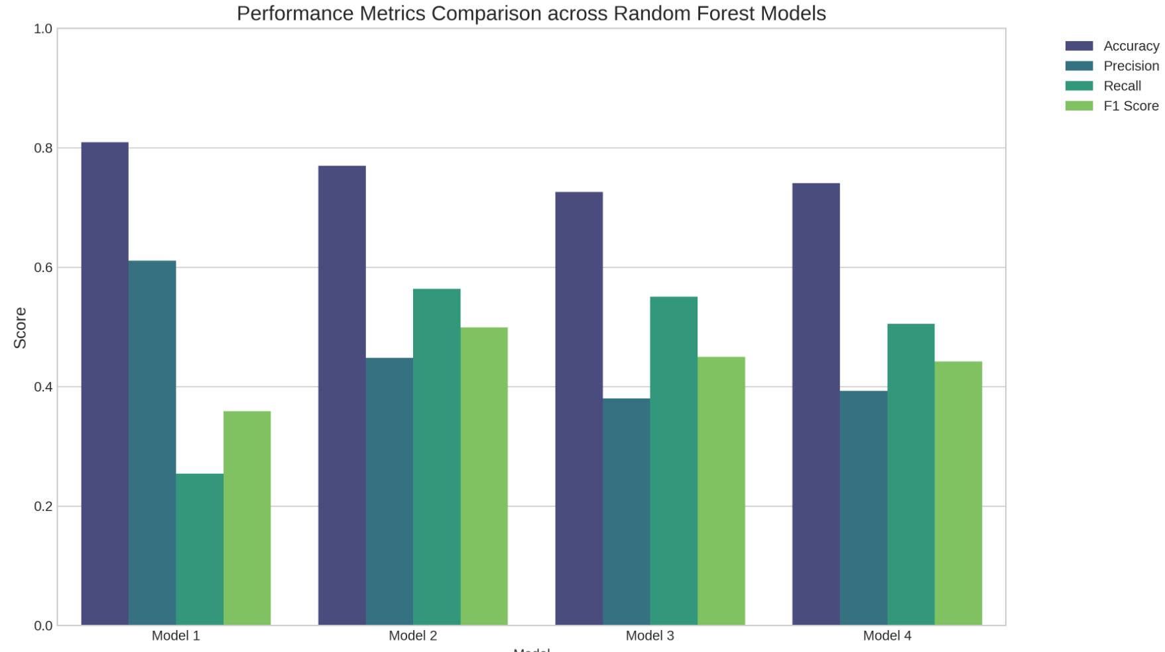
Figure 3 : Bar chart comparing the performance metrics across the four Random Forest models

Comparative Analysis
Model 1 achieved the highest accuracy (80.93%) and precision (61.07%) among all models. However, its recall was relatively low at 25.40%. In the context of churn prediction, a low recall means that the model fails to identify a large portion of customers who are actually going to churn. This implies the high accuracy is misleading.It is primarily driven by the correct classification of the majority class (non-churners). The resulting F1-score of 0.3587 reflects imbalance between precision and recall.
Model 2 demonstrated a significant improvement in identifying churners.Its recall increased upto 56.39%. This improvement was achieved through the application of class weights and hyperparameter tuning. The accuracy (77.00%) and precision (44.79%) decreased compared to the baseline.The F1-score reached its highest value across all models at 0.4993. This indicates that Model 2 provides the most balanced performance.
Model 3, which utilized SMOTE to balance the dataset, also showed improved recall (55.08%) compared to the baseline. However, it resulted in the lowest accuracy (72.60%) and precision (38.01%). The F1-score (0.4498) was lower than that of Model 2.It suggests that while SMOTE helped the model recognize the minority class, it also introduced a higher rate of false positives (predicting churn when the customer does not churn).c
Model 4 attempted to refine the SMOTE approach by adding hyperparameter tuning. This resulted in slight improvements in accuracy (74.07%) and precision (39.29%) over Model 3. But reduced recall to 50.49%. The F1-score (0.4419) remained lower than the Model 2. This suggests that for this specific dataset, algorithmic adjustments (class weights) combined with tuning were more effective than data-level oversampling (SMOTE) combined with tuning.

Confusion Matrix Analysis
To further illustrate the impact of addressing class imbalance, we can examine the confusion matrices. Figure 4 presents confusion matrices comparing the baseline model (Model 1) with the best-performing balanced model (Model 2)
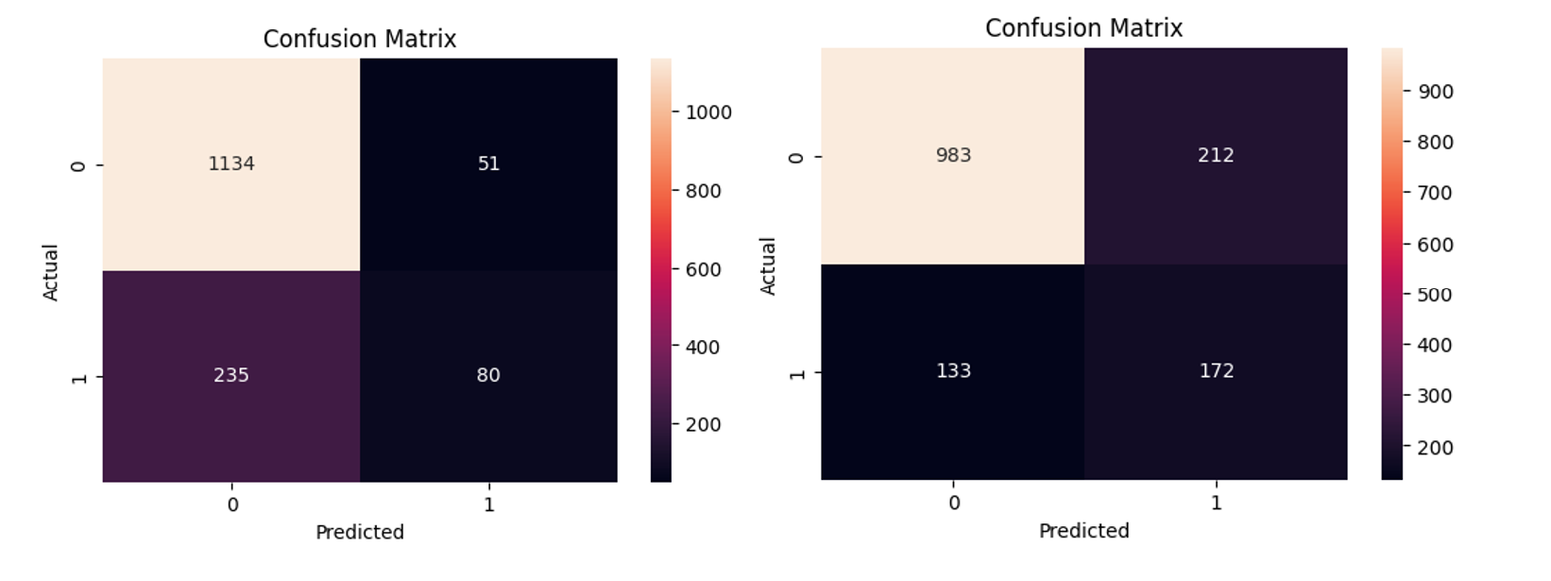
Figure 4 : Confusion matrix for Baseline model Vs best performing model
The confusion matrix for Model 1 clearly shows a high number of True Negatives (correctly predicted non-churners). However, it struggles to correctly detect actual churners (False Negatives). This visualizes the low recall issue, where the model misses many churn events.
The confusion matrix for Model 2 demonstrates a noticeable improvement. The number of correctly identified churners (true positives) has increased. It reflects the improved recall. At the same time there are more false positives. Non-churners are incorrectly classified as churners. This leads to a drop in precision.
In a business context, this trade-off is often acceptable. The cost of missing a churning customer (False Negative) is higher than the cost of unnecessarily targeting a retained customer with a retention campaign (False Positive).

Results and Discussion
Following the comprehensive evaluation of multiple Random Forest and Logistic Regression models, the best-performing model from each approach was identified. For Random Forest, Model 2 (Class Weights + GridSearchCV) demonstrated best performance. For Logistic Regression, Model 3 (SMOTE) identified as the most effective model.
Table 4 presents a summary of the key performance metrics for these two optimal models:
Table 4 : Performance metrics of the best-performing Random Forest and Logistic Regression models.
Model | Primary Technique | Accuracy | Precision | Recall | F1-Score
Random Forest Model 2 | Class Weights + GridSearchCV | 0.7700 | 0.4479 | 0.5639 | 0.4993
Logistic Regression Model 3 | SMOTE | 0.7140 | 0.383 | 0.668 | 0.487

Random Forest Model 2 outperformed Logistic Regression Model 3 across all primary metrics.It achieved a higher F1-score (0.4993 vs. 0.4870) and higher accuracy (0.7700 vs. 0.7140). The higher recall of the Random Forest model (0.5639) is critical for churn prediction.It indicates a better ability to correctly identify at-risk customers thereby reducing the cost of missed churn events.
The high performance of the Random Forest approach is due to its ensemble nature.It captures non-linear relationships that linear models like Logistic Regression may overlook. The use of class_weight and GridSearchCV allowed for direct algorithmic optimization for the imbalanced dataset.
Logistic Regression Model 3 benefited from SMOTE.It remained less effective at differentiating between classes compared to the tuned Random Forest model. Random Forest Model 2 is recommended for deployment offering the best balance for proactive customer retention strategies.
In a business context, the choice between these models depends on the specific priorities. If the primary goal is to minimize false negatives (not missing actual churners) Random Forest Model 2 is preferable. It might incur a slightly higher rate of false positives (predicting churn for customers who will not churn). The cost of missing a churning customer is often higher than the cost of a potentially unnecessary retention effort. The interpretability of Logistic Regression is a notable advantage.But in this case the predictive power of Random Forest, particularly its ability to handle class imbalance effectively, makes it the more suitable choice for this churn prediction task.

Conclusion
Random Forest is the better performing model for this dataset.Logistic Regression remains valuable for interpretability and baseline comparison.
This study systematically investigated the application of Random Forest and Logistic Regression algorithms for customer churn prediction. It emphasizes the critical role of addressing class imbalance. The comparative analysis of various model iterations demonstrated that naive application of machine learning models to imbalanced datasets can lead to misleading performance metrics. High accuracy coupled with low recall for the minority class.
The findings prove the importance of employing techniques such as class weighting and SMOTE to enhance the predictive capability for the minority class. Among the models developed Random Forest Model 2 (Class Weights + GridSearchCV) is the most effective solution. It achieved the highest F1-score .And a strong balance between precision and recall. This model's ability to accurately identify churning customers is important for businesses. It helps to implement timely and effective retention strategies.

Future Work
To improve the predictive power and practical utility of the churn prediction system several directions can be explored in future work. First, more advanced feature engineering could be applied. This may include creating interaction terms or using time-series features based on customer behavior over time. Such features can help reveal patterns related to churn.
Second other algorithms and ensemble methods can be tested. Models such as Gradient Boosting may provide better accuracy. Combining different models could also improve overall performance.
Finally practical improvements can be introduced at the decision level. Dynamic thresholding based on business costs can make predictions useful in real scenarios. Integrating Explainable AI (XAI) methods can improve transparency. This would help stakeholders better understand and trust the model’s predictions.

Appendix

Logistic Regression Notebook

Logistic Regression base code

# Colab-specific setup: mount Drive or upload file
# Mount Google Drive (if dataset is stored there)
# from google.colab import drive
# drive.mount('/content/drive')
# data_path = '/content/drive/MyDrive/Customer Churn new.csv'

# Upload directly :
# from google.colab import files
# uploaded = files.upload()
#data_path = 'Customer Churn new.csv'

# Load libraries
import pandas as pd
import numpy as np
import matplotlib.pyplot as plt
import seaborn as sns

# For resampling and modeling
from sklearn.model_selection import train_test_split, GridSearchCV, cross_validate, StratifiedKFold
from sklearn.preprocessing import StandardScaler
from sklearn.linear_model import LogisticRegression
from sklearn.metrics import confusion_matrix, classification_report, roc_curve, auc, accuracy_score

# Imbalanced-learn for SMOTE
!pip install imbalanced-learn
from imblearn.over_sampling import SMOTE

# Set random seed for reproducibility
np.random.seed(42)

# Load the dataset
df = pd.read_csv("Customer Churn new.csv")
#df = pd.read_csv(data_path)
print(f"Dataset loaded. Shape: {df.shape}")
df.head()

Requirement already satisfied: imbalanced-learn in /usr/local/lib/python3.12/dist-packages (0.14.1)
Requirement already satisfied: numpy<3,>=1.25.2 in /usr/local/lib/python3.12/dist-packages (from imbalanced-learn) (2.0.2)
Requirement already satisfied: scipy<2,>=1.11.4 in /usr/local/lib/python3.12/dist-packages (from imbalanced-learn) (1.16.3)
Requirement already satisfied: scikit-learn<2,>=1.4.2 in /usr/local/lib/python3.12/dist-packages (from imbalanced-learn) (1.6.1)
Requirement already satisfied: sklearn-compat<0.2,>=0.1.5 in /usr/local/lib/python3.12/dist-packages (from imbalanced-learn) (0.1.5)
Requirement already satisfied: joblib<2,>=1.2.0 in /usr/local/lib/python3.12/dist-packages (from imbalanced-learn) (1.5.3)
Requirement already satisfied: threadpoolctl<4,>=2.0.0 in /usr/local/lib/python3.12/dist-packages (from imbalanced-learn) (3.6.0)
Dataset loaded. Shape: (10000, 11)

 | RowNumber | CustomerId | Surname | CreditScore | Geography | Gender | Age | Tenure | Balance | EstimatedSalary | Exited
0 | 747 | 15787619 | Hsieh | 844 | France | Male | 18 | 2 | 160980.03 | 145936.28 | 0
1 | 1620 | 15770309 | McDonald | 656 | France | Male | 18 | 10 | 151762.74 | 127014.32 | 0
2 | 1679 | 15569178 | Kharlamov | 570 | France | Female | 18 | 4 | 82767.42 | 71811.90 | 0
3 | 2022 | 15795519 | Vasiliev | 716 | Germany | Female | 18 | 3 | 128743.80 | 197322.13 | 0
4 | 2137 | 15621893 | Bellucci | 727 | France | Male | 18 | 4 | 133550.67 | 46941.41 | 0

# Brief data inspection
print("Data types and null counts:")
display(df.info())
print("\nClass distribution in target 'Exited':")
print(df['Exited'].value_counts())

Data types and null counts:
<class 'pandas.core.frame.DataFrame'>
RangeIndex: 10000 entries, 0 to 9999
Data columns (total 11 columns):
# Column Non-Null Count Dtype
--- ------ -------------- -----
0 RowNumber 10000 non-null int64
1 CustomerId 10000 non-null int64
2 Surname 10000 non-null object
3 CreditScore 10000 non-null int64
4 Geography 10000 non-null object
5 Gender 10000 non-null object
6 Age 10000 non-null int64
7 Tenure 10000 non-null int64
8 Balance 10000 non-null float64
9 EstimatedSalary 10000 non-null float64
10 Exited 10000 non-null int64
dtypes: float64(2), int64(6), object(3)
memory usage: 859.5+ KB

None
Class distribution in target 'Exited':
Exited
0 7963
1 2037
Name: count, dtype: int64

# Drop identifier columns
df_clean = df.drop(['RowNumber', 'CustomerId', 'Surname'], axis=1)

# Encode categorical features
from sklearn.preprocessing import LabelEncoder
le = LabelEncoder()
df_clean['Geography'] = le.fit_transform(df_clean['Geography'])
df_clean['Gender'] = le.fit_transform(df_clean['Gender'])

# Separate features and target
X = df_clean.drop('Exited', axis=1)
y = df_clean['Exited']

print(f"Features shape: {X.shape}, Target shape: {y.shape}")
display(X.head())

Features shape: (10000, 7), Target shape: (10000,)

 | CreditScore | Geography | Gender | Age | Tenure | Balance | EstimatedSalary
0 | 844 | 0 | 1 | 18 | 2 | 160980.03 | 145936.28
1 | 656 | 0 | 1 | 18 | 10 | 151762.74 | 127014.32
2 | 570 | 0 | 0 | 18 | 4 | 82767.42 | 71811.90
3 | 716 | 1 | 0 | 18 | 3 | 128743.80 | 197322.13
4 | 727 | 0 | 1 | 18 | 4 | 133550.67 | 46941.41

# Check for remaining issues (e.g., nulls, imbalances)
print("Any null values in features?", X.isnull().any().any())
print("Class counts:\n", y.value_counts())

Any null values in features? False
Class counts:
Exited
0 7963
1 2037
Name: count, dtype: int64
# EDA Plot: Target class distribution
plt.figure(figsize=(5,4))
sns.countplot(x=y, palette='muted')
plt.title("Customer Churn Distribution (0=Stay, 1=Churn)")
plt.xlabel("Exited")
plt.ylabel("Count")
plt.show()
print("Churn (1) vs. Stay (0) counts:", y.value_counts().to_dict())

/tmp/ipykernel_13771/3821372251.py:3: FutureWarning:

Passing `palette` without assigning `hue` is deprecated and will be removed in v0.14.0. Assign the `x` variable to `hue` and set `legend=False` for the same effect.

sns.countplot(x=y, palette='muted')

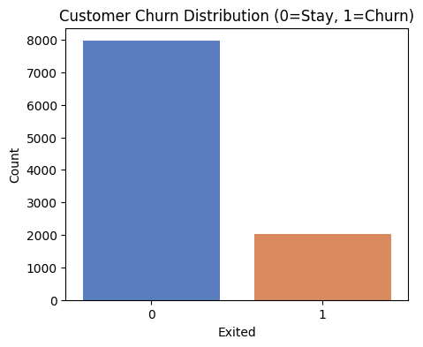
Churn (1) vs. Stay (0) counts: {0: 7963, 1: 2037}

# EDA Plot: Correlation heatmap of features
plt.figure(figsize=(6,5))
corr = X.corr()
sns.heatmap(corr, annot=True, cmap='coolwarm', fmt=".2f")
plt.title("Feature Correlation Heatmap")
plt.show()
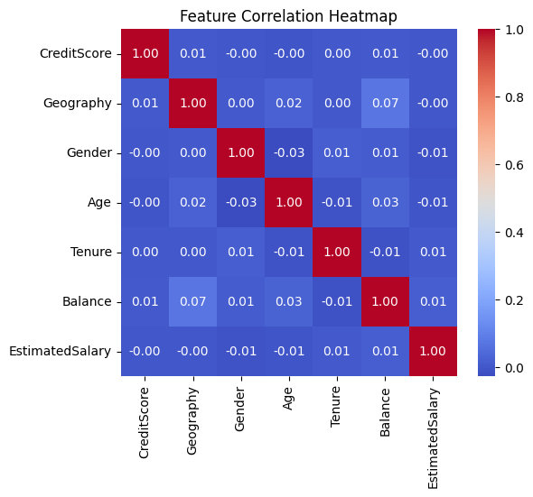
# EDA Plot: Age distribution by churn vs stay
plt.figure(figsize=(6,4))
sns.kdeplot(data=df_clean, x='Age', hue='Exited', fill=True, common_norm=False)
plt.title("Age Distribution by Churn Outcome")
plt.xlabel("Age")
plt.ylabel("Density")
plt.show()
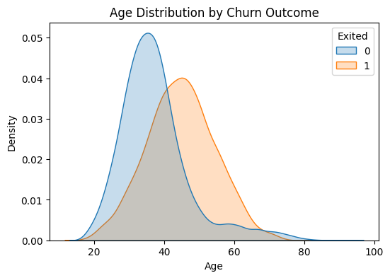

Logistic regression Model 1
# Split data into train/test sets
X_train, X_test, y_train, y_test = train_test_split(
X, y, test_size=0.2, random_state=42, stratify=y
)
print(f"Train size: {X_train.shape[0]}, Test size: {X_test.shape[0]}")

# Scale features
scaler = StandardScaler()
X_train_scaled = scaler.fit_transform(X_train)
X_test_scaled = scaler.transform(X_test)

# Baseline model: default logistic regression (L2 penalty, C=1.0, solver=lbfgs)
baseline_model = LogisticRegression(random_state=42)
baseline_model.fit(X_train_scaled, y_train)
print("Baseline logistic regression trained.")

Train size: 8000, Test size: 2000
Baseline logistic regression trained.

# Evaluate baseline model
y_pred = baseline_model.predict(X_test_scaled)
print("Baseline Model Classification Report:")
print(classification_report(y_test, y_pred, digits=3))
print(f"Accuracy: {accuracy_score(y_test, y_pred):.3f}")

Baseline Model Classification Report:
precision recall f1-score support

0 0.804 0.966 0.878 1593
1 0.379 0.081 0.134 407

accuracy 0.786 2000
macro avg 0.592 0.524 0.506 2000
weighted avg 0.718 0.786 0.726 2000

Accuracy: 0.786

Logistic Regression Model 2
# Model with class_weight='balanced'
cw_model = LogisticRegression(class_weight='balanced', random_state=42)
cw_model.fit(X_train_scaled, y_train)
y_pred_cw = cw_model.predict(X_test_scaled)
print("Class-Weighted Model Report:")
print(classification_report(y_test, y_pred_cw, digits=3))
print(f"Accuracy: {accuracy_score(y_test, y_pred_cw):.3f}")

Class-Weighted Model Report:
precision recall f1-score support

0 0.895 0.719 0.797 1593
1 0.379 0.671 0.484 407

accuracy 0.709 2000
macro avg 0.637 0.695 0.641 2000
weighted avg 0.790 0.709 0.734 2000

Accuracy: 0.709

Logistic Regression Model 3

# Apply SMOTE to oversample training set
smote = SMOTE(random_state=42)
X_train_sm, y_train_sm = smote.fit_resample(X_train_scaled, y_train)
print(f"After SMOTE, training class counts: {np.bincount(y_train_sm)}")

# Model trained on SMOTE-resampled data
sm_model = LogisticRegression(random_state=42)
sm_model.fit(X_train_sm, y_train_sm)
y_pred_sm = sm_model.predict(X_test_scaled)
print("SMOTE Oversampled Model Report:")
print(classification_report(y_test, y_pred_sm, digits=3))
print(f"Accuracy: {accuracy_score(y_test, y_pred_sm):.3f}")

After SMOTE, training class counts: [6370 6370]
SMOTE Oversampled Model Report:
precision recall f1-score support

0 0.895 0.725 0.801 1593
1 0.383 0.668 0.487 407

accuracy 0.714 2000
macro avg 0.639 0.697 0.644 2000
weighted avg 0.791 0.714 0.737 2000

Accuracy: 0.714

Logistic Regression Model 4
# Define parameter grid for GridSearchCV
param_grid = {
'penalty': ['l2'], # 'l1' requires solver='liblinear', here we use 'l2' penalty
'C': [0.01, 0.1, 1, 10], # Inverse regularization strength【18†L728-L732】
'solver': ['lbfgs','liblinear','saga'],
'class_weight': [None, 'balanced']
}
grid = GridSearchCV(
estimator=LogisticRegression(max_iter=500, random_state=42),
param_grid=param_grid,
scoring='roc_auc', # maximize AUC
cv=5, n_jobs=-1, verbose=1
)
grid.fit(X_train_scaled, y_train)
print(f"Best parameters: {grid.best_params_}, Best AUC (CV): {grid.best_score_:.3f}")

Fitting 5 folds for each of 24 candidates, totalling 120 fits
Best parameters: {'C': 10, 'class_weight': 'balanced', 'penalty': 'l2', 'solver': 'saga'}, Best AUC (CV): 0.749
# Evaluate tuned model on the test set
best_model = grid.best_estimator_
y_pred_best = best_model.predict(X_test_scaled)
print("Tuned Model Classification Report:")
print(classification_report(y_test, y_pred_best, digits=3))
print(f"Accuracy: {accuracy_score(y_test, y_pred_best):.3f}")

Tuned Model Classification Report:
precision recall f1-score support

0 0.895 0.719 0.797 1593
1 0.379 0.671 0.484 407

accuracy 0.709 2000
macro avg 0.637 0.695 0.641 2000
weighted avg 0.790 0.709 0.734 2000

Accuracy: 0.709

Confusion Matrix, which is a performance evaluation tool used for classification models such as Logistic Regression. It visually summarizes the predictions made by the model on the test dataset by comparing actual class labels with predicted class labels.

# Predict the class labels for the test dataset using the trained Logistic Regression model
y_pred = baseline_model.predict(X_test_scaled)
# Generate the confusion matrix by comparing actual labels with predicted labels
cm = confusion_matrix(y_test, y_pred)
plt.figure(figsize=(6, 5))
# Plot the confusion matrix as a heatmap for better visualization
sns.heatmap(cm, annot=True, fmt='d', cmap='Blues')
plt.title('Confusion Matrix')
plt.ylabel('Actual')
plt.xlabel('Predicted')
plt.show()
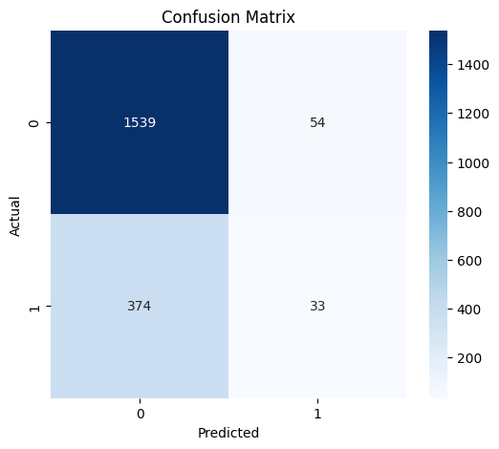

# Baseline model ROC curve and AUC
y_prob = baseline_model.predict_proba(X_test_scaled)[:,1]
fpr, tpr, _ = roc_curve(y_test, y_prob)
roc_auc = auc(fpr, tpr)
plt.figure(figsize=(5,4))
plt.plot(fpr, tpr, label=f'Baseline (AUC={roc_auc:.2f})', color='black')
plt.plot([0,1],[0,1],'k--')
plt.title("ROC Curve - Baseline Logistic")
plt.xlabel("False Positive Rate")
plt.ylabel("True Positive Rate")
plt.legend(loc='lower right')
plt.show()

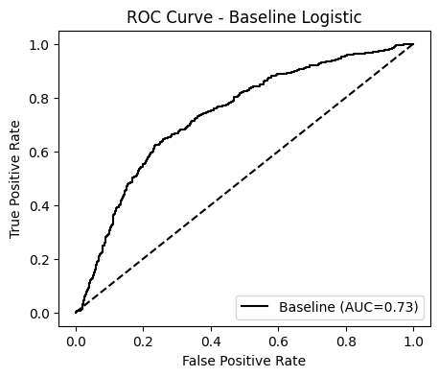
# Compare ROC curves of all models (Baseline, Class-Weight, SMOTE)
plt.figure(figsize=(6,5))
# Baseline
fpr, tpr, _ = roc_curve(y_test, baseline_model.predict_proba(X_test_scaled)[:,1])
plt.plot(fpr, tpr, label=f"Baseline (AUC={auc(fpr,tpr):.2f})", color='black')
# Class-weight
fpr_cw, tpr_cw, _ = roc_curve(y_test, cw_model.predict_proba(X_test_scaled)[:,1])
plt.plot(fpr_cw, tpr_cw, label=f"Class-Weight (AUC={auc(fpr_cw,tpr_cw):.2f})", color='orange')
# SMOTE
fpr_sm, tpr_sm, _ = roc_curve(y_test, sm_model.predict_proba(X_test_scaled)[:,1])
plt.plot(fpr_sm, tpr_sm, label=f"SMOTE (AUC={auc(fpr_sm,tpr_sm):.2f})", color='green')

plt.plot([0,1],[0,1],'k--')
plt.title("ROC Curves: Baseline vs. Class-Weight vs. SMOTE")
plt.xlabel("False Positive Rate")
plt.ylabel("True Positive Rate")
plt.legend(loc='lower right')
plt.show()
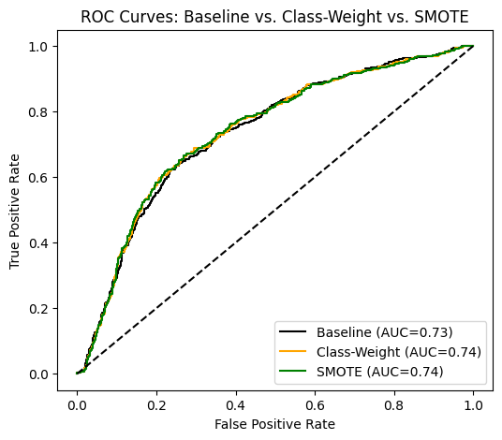
# Include tuned model in ROC comparison
fpr_best, tpr_best, _ = roc_curve(y_test, best_model.predict_proba(X_test_scaled)[:,1])
plt.figure(figsize=(6,5))
plt.plot(fpr, tpr, color='black', linestyle='--', label=f"Baseline (AUC={auc(fpr,tpr):.2f})")
plt.plot(fpr_best, tpr_best, color='red', label=f"Tuned (AUC={auc(fpr_best,tpr_best):.2f})")
plt.plot([0,1],[0,1],'k:')
plt.title("ROC: Baseline vs. Tuned Logistic")
plt.xlabel("FPR")
plt.ylabel("TPR")
plt.legend()
plt.show()
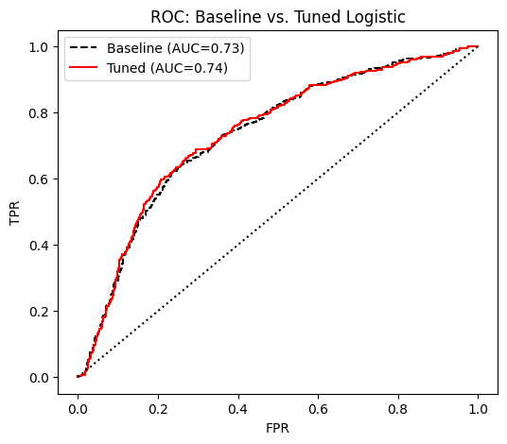
Cross-Validation Evaluation To assess model stability, we perform k-fold cross-validation and report mean ± std of key metrics (accuracy, precision, recall, AUC). We use 5-fold CV on the training data for consistency.
cv = 5
scoring = ['accuracy', 'precision_macro', 'recall_macro', 'roc_auc']
# Baseline CV
scores_base = cross_validate(baseline_model, X_train_scaled, y_train, cv=cv, scoring=scoring)
# Class-weight CV
scores_cw = cross_validate(cw_model, X_train_scaled, y_train, cv=cv, scoring=scoring)
# SMOTE pipeline CV (resample inside each fold)
# We use a custom approach since cross_validate doesn't support resampling directly:
from sklearn.base import clone

def cross_val_smote(model, X, y, cv):
accuracies = []
precisions = []
recalls = []
aucs = []
skf = StratifiedKFold(n_splits=cv, shuffle=True, random_state=42)
for train_idx, test_idx in skf.split(X, y):
X_tr, X_te = X[train_idx], X[test_idx]
y_tr, y_te = y[train_idx], y[test_idx]
X_tr_res, y_tr_res = SMOTE(random_state=42).fit_resample(X_tr, y_tr)
m = clone(model).fit(X_tr_res, y_tr_res)
y_pred = m.predict(X_te)
y_prob = m.predict_proba(X_te)[:,1]
accuracies.append(accuracy_score(y_te, y_pred))
precisions.append(precision := (classification_report(y_te, y_pred, output_dict=True)['macro avg']['precision']))
recalls.append(recall := (classification_report(y_te, y_pred, output_dict=True)['macro avg']['recall']))
fpr, tpr, _ = roc_curve(y_te, y_prob)
aucs.append(auc(fpr, tpr))
return np.array(accuracies), np.array(precisions), np.array(recalls), np.array(aucs)

# Perform SMOTE CV
acc_sm, prec_sm, rec_sm, auc_sm = cross_val_smote(LogisticRegression(random_state=42), X_train_scaled, y_train.values, cv)
# Tuned model CV (with best params)
scores_best = cross_validate(best_model, X_train_scaled, y_train, cv=cv, scoring=scoring)

# Summarize CV results
import numpy as np
cv_results = pd.DataFrame({
'Model': ['Baseline', 'Class-Weight', 'SMOTE', 'Tuned'],
'Accuracy (mean±std)': [
f"{scores_base['test_accuracy'].mean():.3f}±{scores_base['test_accuracy'].std():.3f}",
f"{scores_cw['test_accuracy'].mean():.3f}±{scores_cw['test_accuracy'].std():.3f}",
f"{acc_sm.mean():.3f}±{acc_sm.std():.3f}",
f"{scores_best['test_accuracy'].mean():.3f}±{scores_best['test_accuracy'].std():.3f}"
],
'Precision (mean±std)': [
f"{scores_base['test_precision_macro'].mean():.3f}±{scores_base['test_precision_macro'].std():.3f}",
f"{scores_cw['test_precision_macro'].mean():.3f}±{scores_cw['test_precision_macro'].std():.3f}",
f"{prec_sm.mean():.3f}±{prec_sm.std():.3f}",
f"{scores_best['test_precision_macro'].mean():.3f}±{scores_best['test_precision_macro'].std():.3f}"
],
'Recall (mean±std)': [
f"{scores_base['test_recall_macro'].mean():.3f}±{scores_base['test_recall_macro'].std():.3f}",
f"{scores_cw['test_recall_macro'].mean():.3f}±{scores_cw['test_recall_macro'].std():.3f}",
f"{rec_sm.mean():.3f}±{rec_sm.std():.3f}",
f"{scores_best['test_recall_macro'].mean():.3f}±{scores_best['test_recall_macro'].std():.3f}"
],
'ROC AUC (mean±std)': [
f"{scores_base['test_roc_auc'].mean():.3f}±{scores_base['test_roc_auc'].std():.3f}",
f"{scores_cw['test_roc_auc'].mean():.3f}±{scores_cw['test_roc_auc'].std():.3f}",
f"{auc_sm.mean():.3f}±{auc_sm.std():.3f}",
f"{scores_best['test_roc_auc'].mean():.3f}±{scores_best['test_roc_auc'].std():.3f}"
]
})
display(cv_results)

 | Model | Accuracy (mean±std) | Precision (mean±std) | Recall (mean±std) | ROC AUC (mean±std)
0 | Baseline | 0.785±0.003 | 0.594±0.009 | 0.527±0.005 | 0.745±0.012
1 | Class-Weight | 0.707±0.010 | 0.637±0.011 | 0.695±0.017 | 0.749±0.012
2 | SMOTE | 0.710±0.006 | 0.639±0.010 | 0.699±0.017 | 0.750±0.016
3 | Tuned | 0.707±0.010 | 0.637±0.011 | 0.695±0.017 | 0.749±0.012
# Aggregate test-set metrics and best params into a summary table
models = ['Baseline', 'Class-Weight', 'SMOTE', 'Tuned']
accuracies = [accuracy_score(y_test, baseline_model.predict(X_test_scaled)),
accuracy_score(y_test, cw_model.predict(X_test_scaled)),
accuracy_score(y_test, sm_model.predict(X_test_scaled)),
accuracy_score(y_test, best_model.predict(X_test_scaled))]
precisions = [precision := (classification_report(y_test, baseline_model.predict(X_test_scaled), output_dict=True)['macro avg']['precision']),
(classification_report(y_test, cw_model.predict(X_test_scaled), output_dict=True)['macro avg']['precision']),
(classification_report(y_test, sm_model.predict(X_test_scaled), output_dict=True)['macro avg']['precision']),
(classification_report(y_test, best_model.predict(X_test_scaled), output_dict=True)['macro avg']['precision'])]
recalls = [(classification_report(y_test, baseline_model.predict(X_test_scaled), output_dict=True)['macro avg']['recall']),
(classification_report(y_test, cw_model.predict(X_test_scaled), output_dict=True)['macro avg']['recall']),
(classification_report(y_test, sm_model.predict(X_test_scaled), output_dict=True)['macro avg']['recall']),
(classification_report(y_test, best_model.predict(X_test_scaled), output_dict=True)['macro avg']['recall'])]
aucs = [auc(fpr, tpr),
auc(fpr_cw, tpr_cw),
auc(fpr_sm, tpr_sm),
auc(fpr_best, tpr_best)]
solvers = ['lbfgs', 'lbfgs', 'lbfgs', grid.best_params_['solver']]
Cs = [1.0, 1.0, 1.0, grid.best_params_['C']]
class_weights = ['None', 'balanced', 'None', str(grid.best_params_['class_weight'])]
oversample = ['No', 'No', 'Yes', 'No']
summary = pd.DataFrame({
'Model': models,
'Solver': solvers,
'C': Cs,
'ClassWeight': class_weights,
'Oversampling': oversample,
'Accuracy': np.round(accuracies,3),
'Precision': np.round(precisions,3),
'Recall': np.round(recalls,3),
'AUC': np.round(aucs,3)
})
display(summary)

 | Model | Solver | C | ClassWeight | Oversampling | Accuracy | Precision | Recall | AUC
0 | Baseline | lbfgs | 1.0 | None | No | 0.786 | 0.592 | 0.524 | 0.734
1 | Class-Weight | lbfgs | 1.0 | balanced | No | 0.709 | 0.637 | 0.695 | 0.737
2 | SMOTE | lbfgs | 1.0 | None | Yes | 0.714 | 0.639 | 0.697 | 0.737
3 | Tuned | saga | 10.0 | balanced | No | 0.709 | 0.637 | 0.695 | 0.737
# Bar chart of key metrics by model
metrics = ['Accuracy', 'Precision', 'Recall','AUC']
x = np.arange(len(models))
width = 0.2

plt.figure(figsize=(7,5))
for i, metric in enumerate(metrics):
values = summary[metric]
plt.bar(x + (i-1.5)*width, values, width, label=metric)
plt.xticks(x, models)
plt.ylabel("Score")
plt.ylim(0,1.0)
plt.title("Model Performance Comparison")
plt.legend(loc='lower right')
plt.show()
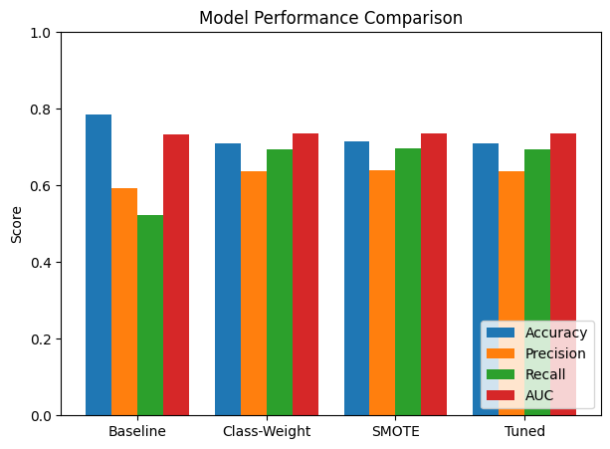

Random Forest Notebook
Random Forest Model 1
import pandas as pd
import numpy as np

from sklearn.model_selection import train_test_split
from sklearn.preprocessing import LabelEncoder, StandardScaler
from sklearn.ensemble import RandomForestClassifier

from sklearn.metrics import accuracy_score, precision_score, recall_score, f1_score, confusion_matrix, classification_report
df = pd.read_csv("Customer Churn new.csv")
df.head()
if 'customerID' in df.columns:
df.drop('customerID', axis=1, inplace=True)
df = df.dropna()
le = LabelEncoder()

for col in df.columns:
if df[col].dtype == 'object':
df[col] = le.fit_transform(df[col])
X = df.drop('Exited', axis=1)
y = df['Exited']
X_train, X_temp, y_train, y_temp = train_test_split(
X, y, test_size=0.25, random_state=42
)
X_val, X_test, y_val, y_test = train_test_split(
X_temp, y_temp, test_size=0.6, random_state=42
)
scaler = StandardScaler()

X_train = scaler.fit_transform(X_train)
X_val = scaler.transform(X_val)
X_test = scaler.transform(X_test)
rf_model = RandomForestClassifier(
n_estimators=100,
random_state=42
)

rf_model.fit(X_train, y_train)
y_val_pred = rf_model.predict(X_val)

print("Validation Results:")
print("Accuracy:", accuracy_score(y_val, y_val_pred))
print("Precision:", precision_score(y_val, y_val_pred))
print("Recall:", recall_score(y_val, y_val_pred))
print("F1 Score:", f1_score(y_val, y_val_pred))
y_test_pred = rf_model.predict(X_test)

print("\nTest Results:")
print("Accuracy:", accuracy_score(y_test, y_test_pred))
print("Precision:", precision_score(y_test, y_test_pred))
print("Recall:", recall_score(y_test, y_test_pred))
print("F1 Score:", f1_score(y_test, y_test_pred))
cm = confusion_matrix(y_test, y_test_pred)
print("\nConfusion Matrix:\n", cm)
print("\nClassification Report:\n")
print(classification_report(y_test, y_test_pred))
import matplotlib.pyplot as plt
import seaborn as sns

plt.figure(figsize=(6,4))
sns.heatmap(cm, annot=True, fmt='d')
plt.xlabel("Predicted")
plt.ylabel("Actual")
plt.title("Confusion Matrix")
plt.show()

Random Forest Model 2
import pandas as pd
import numpy as np

from sklearn.model_selection import train_test_split
from sklearn.preprocessing import LabelEncoder, StandardScaler
from sklearn.ensemble import RandomForestClassifier

from sklearn.metrics import accuracy_score, precision_score, recall_score, f1_score, confusion_matrix, classification_report
df = pd.read_csv("Customer Churn new.csv")
df.head()
#PReprocessing
# Drop unnecessary columns
df.drop(['RowNumber', 'CustomerId', 'Surname'], axis=1, inplace=True)

# Handle missing values
df = df.dropna()

# Encode categorical variables
le = LabelEncoder()

for col in df.columns:
if df[col].dtype == 'object':
df[col] = le.fit_transform(df[col])
#Features & Target
X = df.drop('Exited', axis=1)
y = df['Exited']
#Stratified Split
X_train, X_temp, y_train, y_temp = train_test_split(
X, y, test_size=0.25, stratify=y, random_state=42
)

X_val, X_test, y_val, y_test = train_test_split(
X_temp, y_temp, test_size=0.6, stratify=y_temp, random_state=42
)
#Improved Random Forest (with balancing)
rf = RandomForestClassifier(
class_weight='balanced',
random_state=42
)
from sklearn.model_selection import GridSearchCV

param_grid = {
'n_estimators': [100, 200],
'max_depth': [5, 10, None],
'min_samples_split': [2, 5],
'min_samples_leaf': [1, 2]
}

grid = GridSearchCV(
rf,
param_grid,
cv=5,
scoring='f1',
n_jobs=-1
)

grid.fit(X_train, y_train)

best_model = grid.best_estimator_

print("Best Parameters:", grid.best_params_)
y_val_pred = best_model.predict(X_val)

print("Validation Results:")
print("Accuracy:", accuracy_score(y_val, y_val_pred))
print("Precision:", precision_score(y_val, y_val_pred))
print("Recall:", recall_score(y_val, y_val_pred))
print("F1 Score:", f1_score(y_val, y_val_pred))
y_test_pred = best_model.predict(X_test)

print("\nTest Results:")
print("Accuracy:", accuracy_score(y_test, y_test_pred))
print("Precision:", precision_score(y_test, y_test_pred))
print("Recall:", recall_score(y_test, y_test_pred))
print("F1 Score:", f1_score(y_test, y_test_pred))
y_test_pred = best_model.predict(X_test)

print("\nTest Results:")
print("Accuracy:", accuracy_score(y_test, y_test_pred))
print("Precision:", precision_score(y_test, y_test_pred))
print("Recall:", recall_score(y_test, y_test_pred))
print("F1 Score:", f1_score(y_test, y_test_pred))
cm = confusion_matrix(y_test, y_test_pred)
print("\nConfusion Matrix:\n", cm)
print("\nClassification Report:\n")
print(classification_report(y_test, y_test_pred))
import matplotlib.pyplot as plt
import seaborn as sns

plt.figure(figsize=(6,4))
sns.heatmap(cm, annot=True, fmt='d')
plt.xlabel("Predicted")
plt.ylabel("Actual")
plt.title("Confusion Matrix")
plt.show()

Random Forest Model 3
Use SMOTE for address class imbalance
!pip install imbalanced-learn
import pandas as pd
import numpy as np

from sklearn.model_selection import train_test_split
from sklearn.preprocessing import LabelEncoder

from sklearn.ensemble import RandomForestClassifier

from sklearn.metrics import accuracy_score, precision_score, recall_score, f1_score, confusion_matrix, classification_report

from imblearn.over_sampling import SMOTE
df = pd.read_csv("Customer Churn new.csv")
df.head()
#PReprocessing
# Drop unnecessary columns
df.drop(['RowNumber', 'CustomerId', 'Surname'], axis=1, inplace=True)

# Handle missing values
df = df.dropna()

# Encode categorical variables
le = LabelEncoder()

for col in df.columns:
if df[col].dtype == 'object':
df[col] = le.fit_transform(df[col])
#Features & Target
X = df.drop('Exited', axis=1)
y = df['Exited']
#Stratified Split
X_train, X_temp, y_train, y_temp = train_test_split(
X, y, test_size=0.25, stratify=y, random_state=42
)

X_val, X_test, y_val, y_test = train_test_split(
X_temp, y_temp, test_size=0.6, stratify=y_temp, random_state=42
)
#Apply SMOTE (ONLY on training data
smote = SMOTE(random_state=42)

X_train_sm, y_train_sm = smote.fit_resample(X_train, y_train)

print("Before SMOTE:", y_train.value_counts())
print("After SMOTE:", pd.Series(y_train_sm).value_counts())
rf_model = RandomForestClassifier(
n_estimators=200,
max_depth=10,
random_state=42
)

rf_model.fit(X_train_sm, y_train_sm)
y_val_pred = rf_model.predict(X_val)

print("Validation Results:")
print("Accuracy:", accuracy_score(y_val, y_val_pred))
print("Precision:", precision_score(y_val, y_val_pred))
print("Recall:", recall_score(y_val, y_val_pred))
print("F1 Score:", f1_score(y_val, y_val_pred))
y_test_pred = rf_model.predict(X_test)

print("\nTest Results:")
print("Accuracy:", accuracy_score(y_test, y_test_pred))
print("Precision:", precision_score(y_test, y_test_pred))
print("Recall:", recall_score(y_test, y_test_pred))
print("F1 Score:", f1_score(y_test, y_test_pred))
y_test_pred = rf_model.predict(X_test)

print("\nTest Results:")
print("Accuracy:", accuracy_score(y_test, y_test_pred))
print("Precision:", precision_score(y_test, y_test_pred))
print("Recall:", recall_score(y_test, y_test_pred))
print("F1 Score:", f1_score(y_test, y_test_pred))
cm = confusion_matrix(y_test, y_test_pred)
print("\nConfusion Matrix:\n", cm)
print("\nClassification Report:\n")
print(classification_report(y_test, y_test_pred))
import matplotlib.pyplot as plt
import seaborn as sns

plt.figure(figsize=(6,4))
sns.heatmap(cm, annot=True, fmt='d')
plt.xlabel("Predicted")
plt.ylabel("Actual")
plt.title("Confusion Matrix")
plt.show()

Random Forest Model 4
Use SMOTE for address class imbalance + GridSearchCV
!pip install imbalanced-learn
import pandas as pd
import numpy as np

from sklearn.model_selection import train_test_split, GridSearchCV
from sklearn.preprocessing import LabelEncoder

from sklearn.ensemble import RandomForestClassifier

from sklearn.metrics import accuracy_score, precision_score, recall_score, f1_score, confusion_matrix, classification_report

from imblearn.over_sampling import SMOTE

df = pd.read_csv("Customer Churn new.csv")
df.head()
#PReprocessing
# Drop unnecessary columns
df.drop(['RowNumber', 'CustomerId', 'Surname'], axis=1, inplace=True)

# Handle missing values
df = df.dropna()

# Encode categorical variables
le = LabelEncoder()

for col in df.columns:
if df[col].dtype == 'object':
df[col] = le.fit_transform(df[col])
#Features & Target
X = df.drop('Exited', axis=1)
y = df['Exited']
#Stratified Split
X_train, X_temp, y_train, y_temp = train_test_split(
X, y, test_size=0.25, stratify=y, random_state=42
)

X_val, X_test, y_val, y_test = train_test_split(
X_temp, y_temp, test_size=0.6, stratify=y_temp, random_state=42
)
#Apply SMOTE (ONLY on training data
smote = SMOTE(random_state=42)

X_train_sm, y_train_sm = smote.fit_resample(X_train, y_train)

print("Before SMOTE:", y_train.value_counts())
print("After SMOTE:", pd.Series(y_train_sm).value_counts())
rf = RandomForestClassifier(random_state=42)
param_grid = {
'n_estimators': [100, 200],
'max_depth': [5, 10, None],
'min_samples_split': [2, 5],
'min_samples_leaf': [1, 2]
}
#GridSearchCV (Tuning)
grid = GridSearchCV(
estimator=rf,
param_grid=param_grid,
cv=5,
scoring='f1',
n_jobs=-1
)

grid.fit(X_train_sm, y_train_sm)

best_model = grid.best_estimator_

print("Best Parameters:", grid.best_params_)
y_val_pred = best_model.predict(X_val)

print("Validation Results:")
print("Accuracy:", accuracy_score(y_val, y_val_pred))
print("Precision:", precision_score(y_val, y_val_pred))
print("Recall:", recall_score(y_val, y_val_pred))
print("F1 Score:", f1_score(y_val, y_val_pred))
y_test_pred = best_model.predict(X_test)

print("\nTest Results:")
print("Accuracy:", accuracy_score(y_test, y_test_pred))
print("Precision:", precision_score(y_test, y_test_pred))
print("Recall:", recall_score(y_test, y_test_pred))
print("F1 Score:", f1_score(y_test, y_test_pred))
y_test_pred = best_model.predict(X_test)

print("\nTest Results:")
print("Accuracy:", accuracy_score(y_test, y_test_pred))
print("Precision:", precision_score(y_test, y_test_pred))
print("Recall:", recall_score(y_test, y_test_pred))
print("F1 Score:", f1_score(y_test, y_test_pred))
cm = confusion_matrix(y_test, y_test_pred)
print("\nConfusion Matrix:\n", cm)
print("\nClassification Report:\n")
print(classification_report(y_test, y_test_pred))
import matplotlib.pyplot as plt
import seaborn as sns

plt.figure(figsize=(6,4))
sns.heatmap(cm, annot=True, fmt='d')
plt.xlabel("Predicted")
plt.ylabel("Actual")
plt.title("Confusion Matrix")
plt.show()

References
- https://www.kaggle.com/datasets/willianoliveiragibin/customer-churn/data
- https://scikit-learn.org/stable/
- https://www.datacamp.com/tutorial

